ASSIGNMENT – 9.4
DAYYALA.VIDHU SREE
2303A52400
Batch – 41

Task 1: Auto-Generating Function Documentation in a Shared Codebase

Scenario
You have joined a development team where several utility functions are already implemented, but the code lacks proper documentation. New team members are struggling to understand how these functions should be used.

Prompt
Generate a Python code containing multiple functions without any docstrings.
Code (Before Documentation)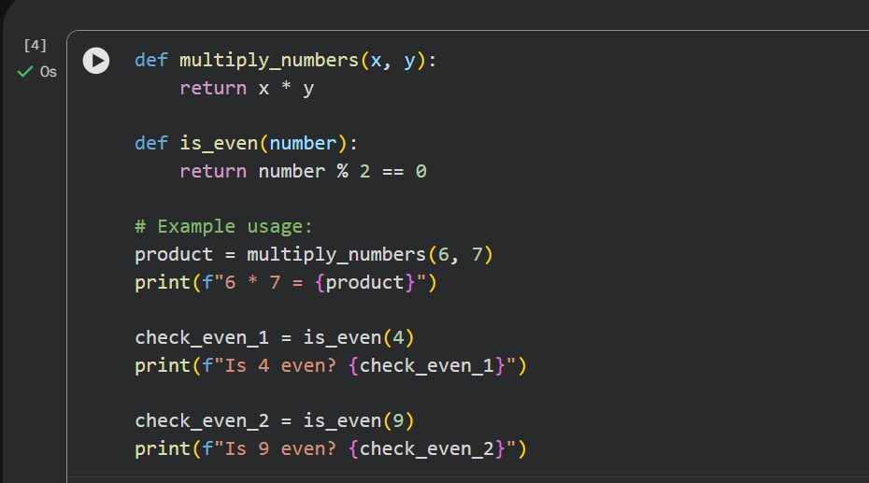

Using an AI-assisted coding tool
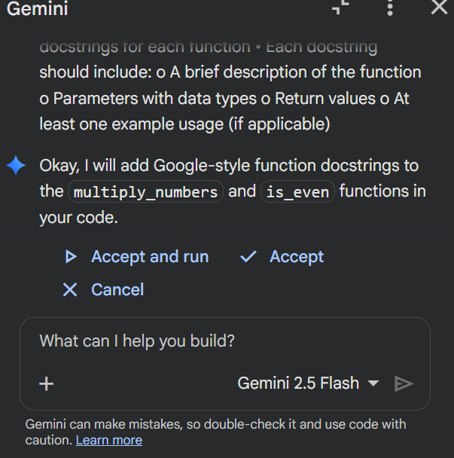

Code (After Documentation)
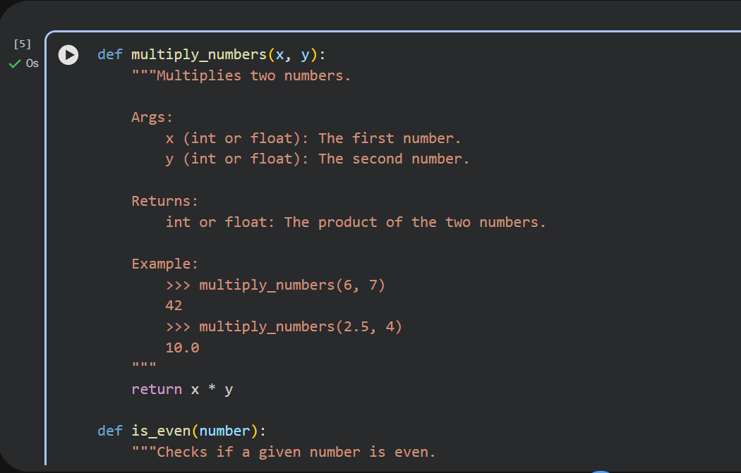
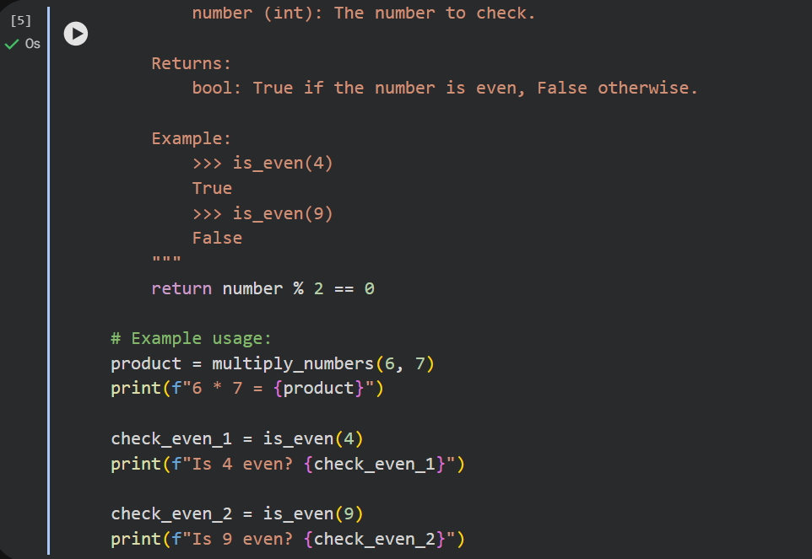

Output
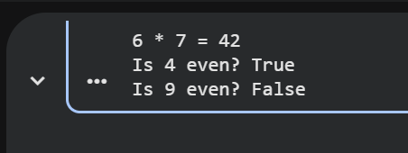

Justification
AI-generated docstrings improved readability and clarified function usage without modifying logic. Google-style documentation makes the code easier for team members to understand.

Task 2: Enhancing Readability Through AI-Generated Inline Comments

Scenario
A Python program contains complex logic that works correctly but is difficult to understand at first glance. Future maintainers may find it hard to debug or extend this code.

Prompt
provide a Python script containing Loops , Conditional logic Algorithms (such as Fibonacci sequence, sorting, or searching)

Code (Before Inline Comments)
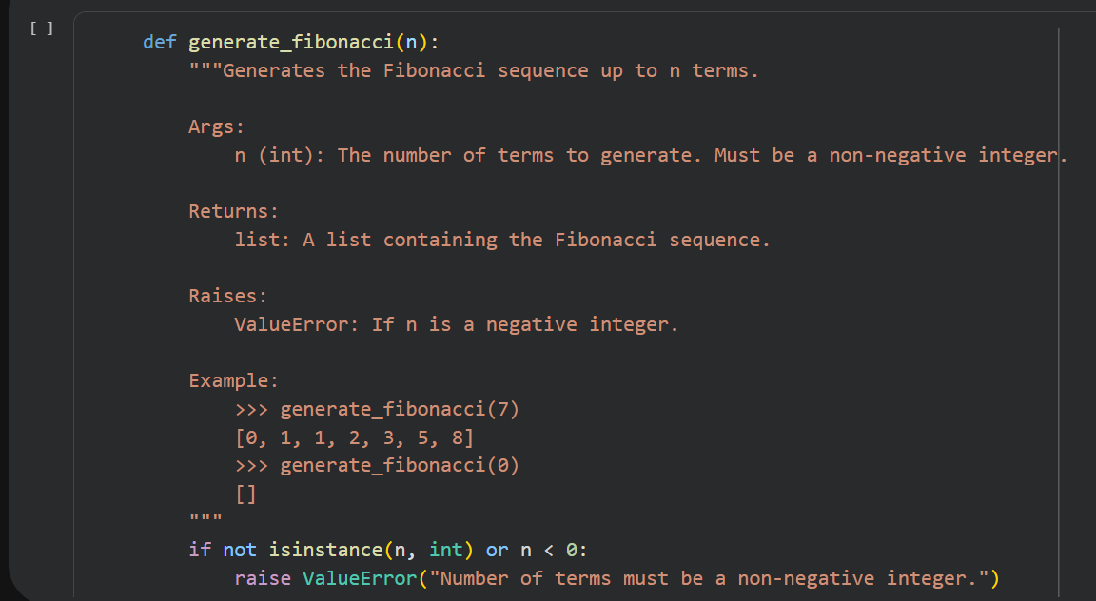
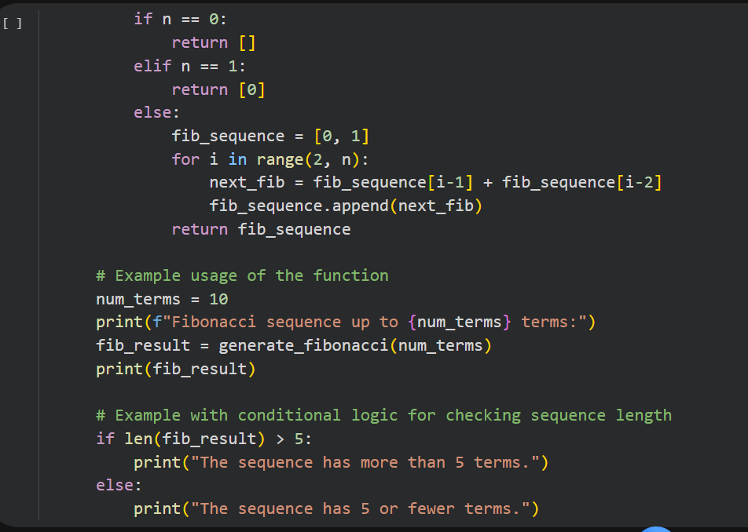
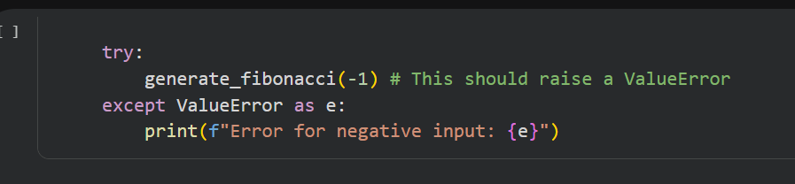

Using an AI-assisted coding tool
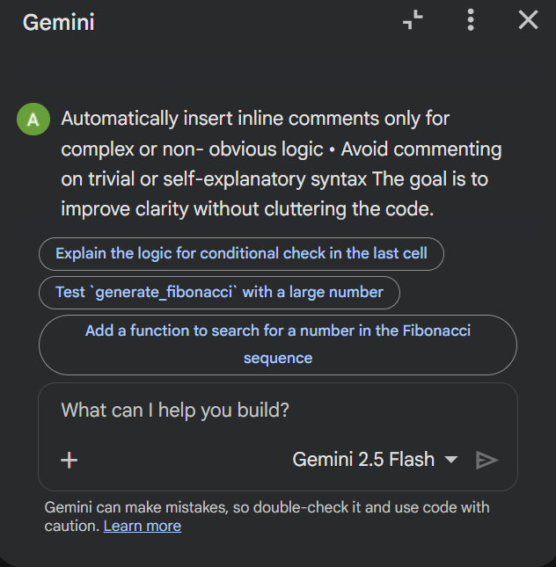

Code (After Inline Comments)
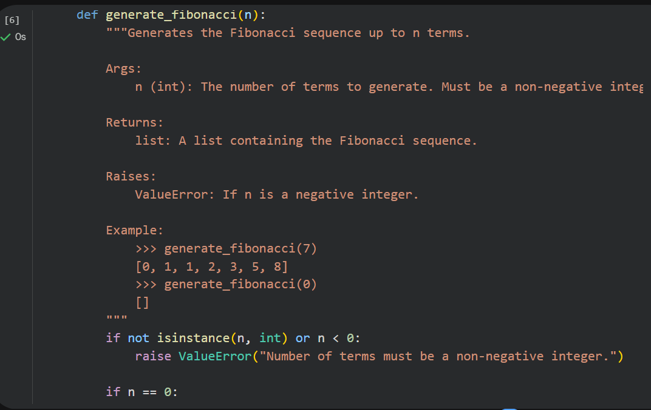
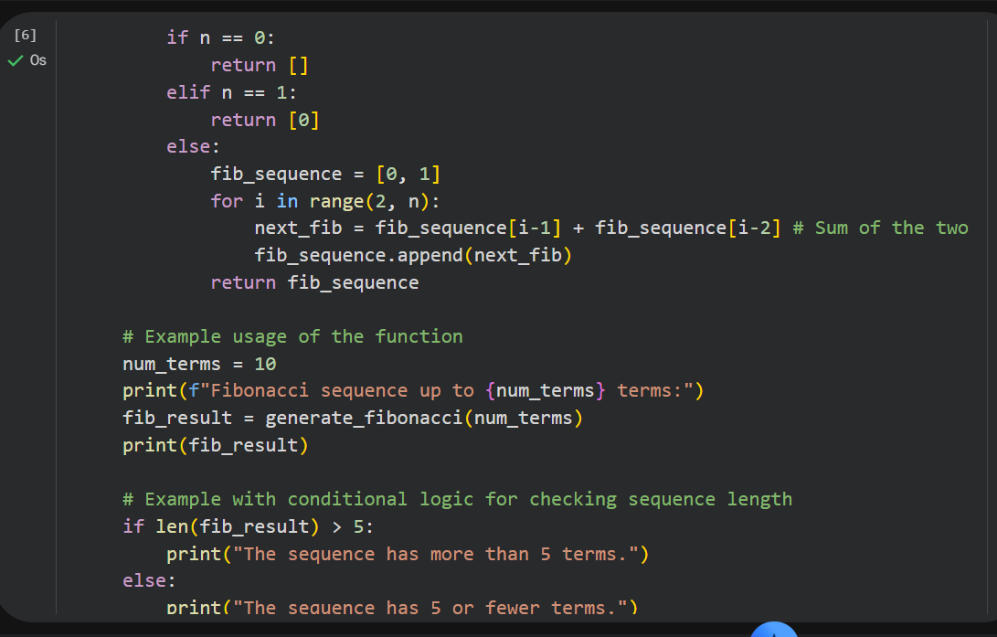
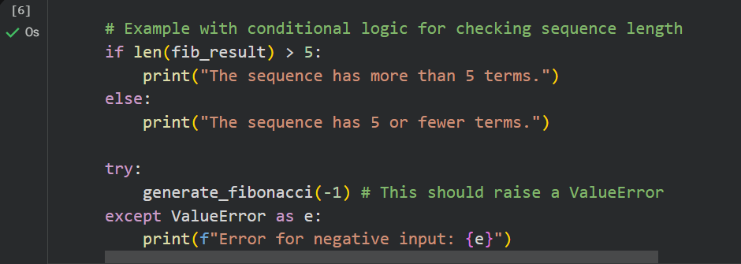

Output
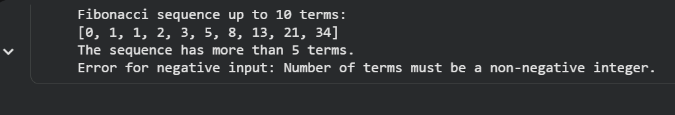

Justification
AI inserted meaningful comments explaining algorithm logic rather than syntax, improving maintainability without clutter.

Task 3: Generating Module-Level Documentation for a Python Package

Scenario
Your team is preparing a Python module to be shared internally (or uploaded to a repository). Anyone opening the file should immediately understand its purpose and structure.

Prompt
Generate a Python module containing functions and automatically insert a comprehensive module-level docstring that describes its purpose, required libraries, key functions, and example usage.

Python Module
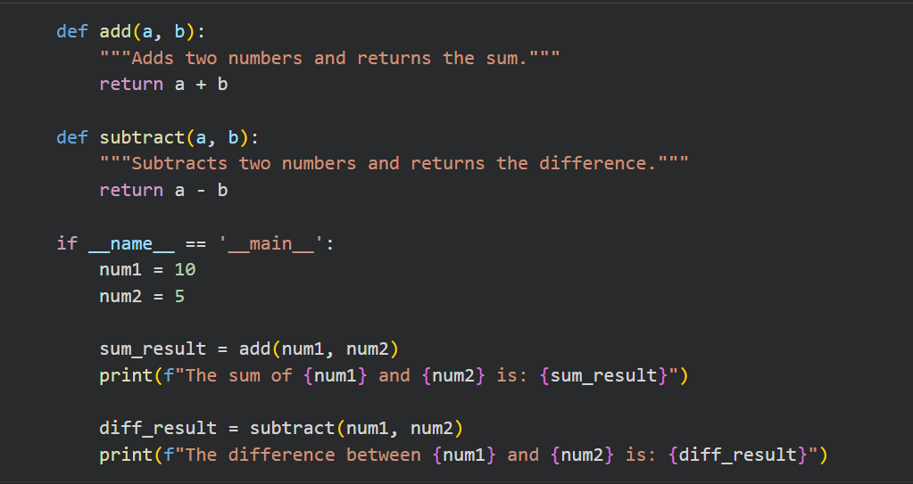

Using an AI-assisted coding tool to generate a module-level docstring
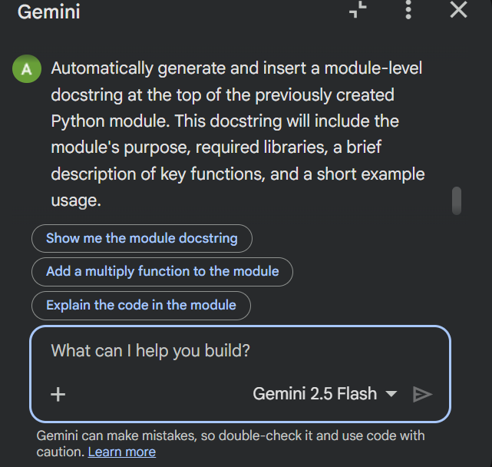

After using AI tool
multi-line module-level docstring
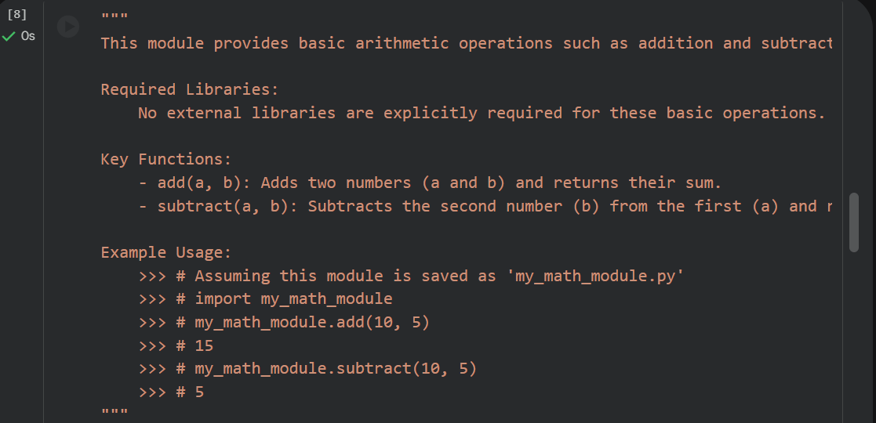
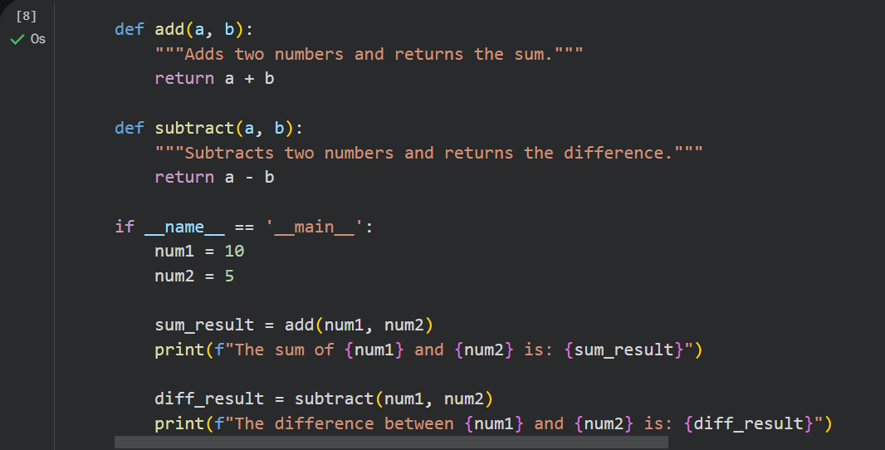

Summary
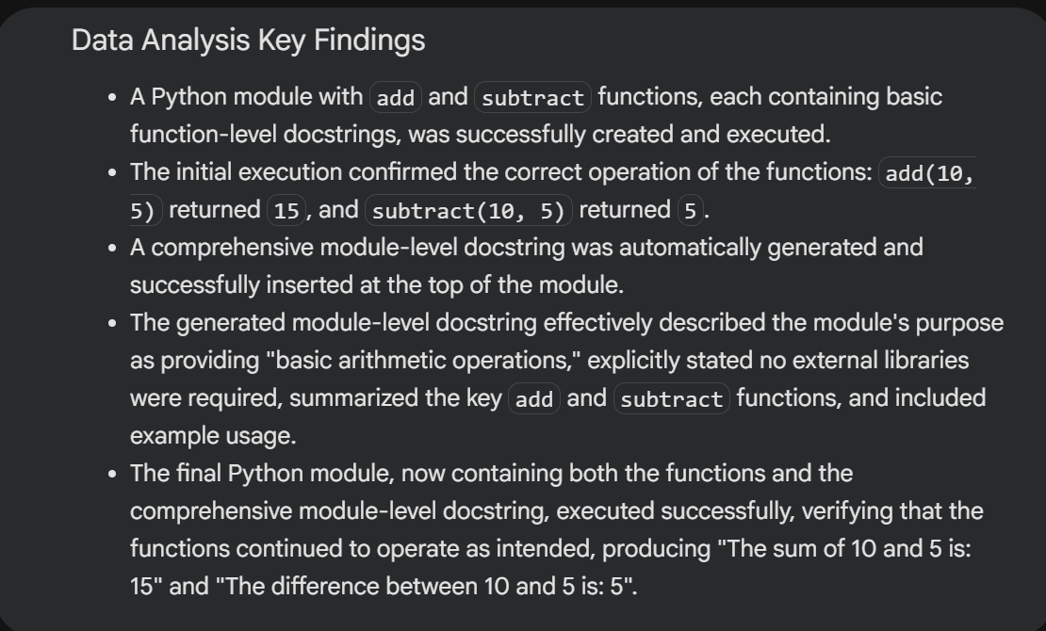
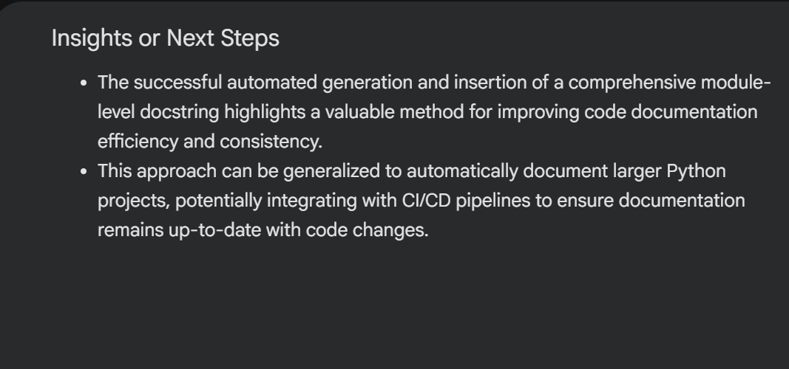

Output


Justification
Module-level documentation provides an overview of purpose, structure, and usage, which is essential for shared repositories.

Task 4: Converting Developer Comments into Structured Docstrings

Scenario
In a legacy project, developers have written long explanatory comments inside functions instead of proper docstrings. The team now wants to standardize documentation.

Prompt
Give a Python script where functions contain detailed inline comments explaining their logic.

Python script where functions contain detailed inline comments explaining their logic.
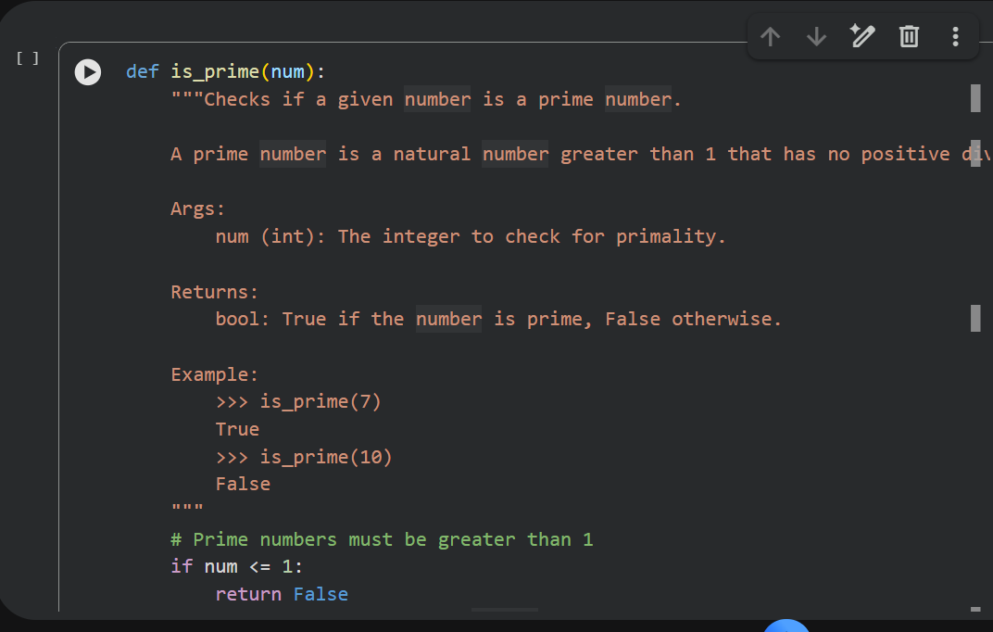
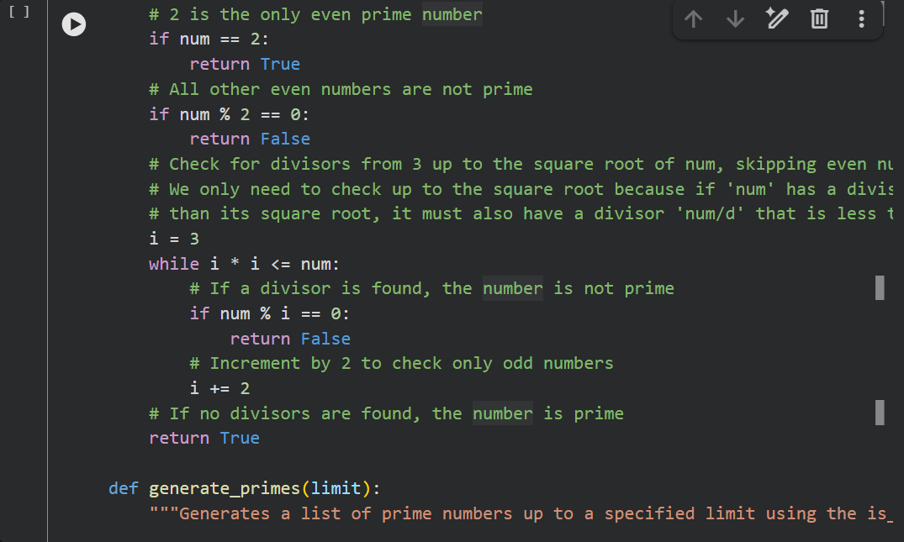
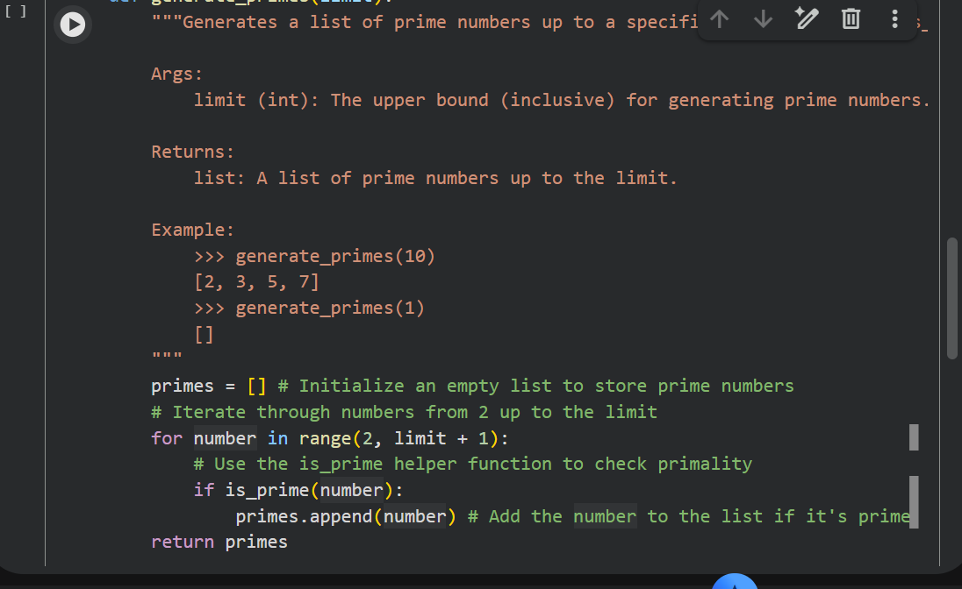
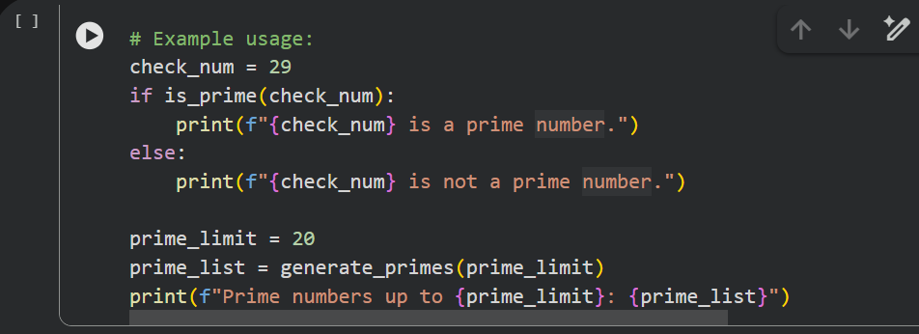

Using AI to:
• Automatically convert these comments into structured Google-style or NumPy-style docstrings
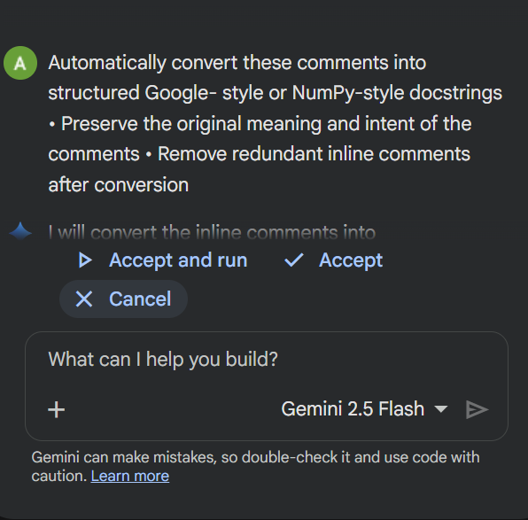

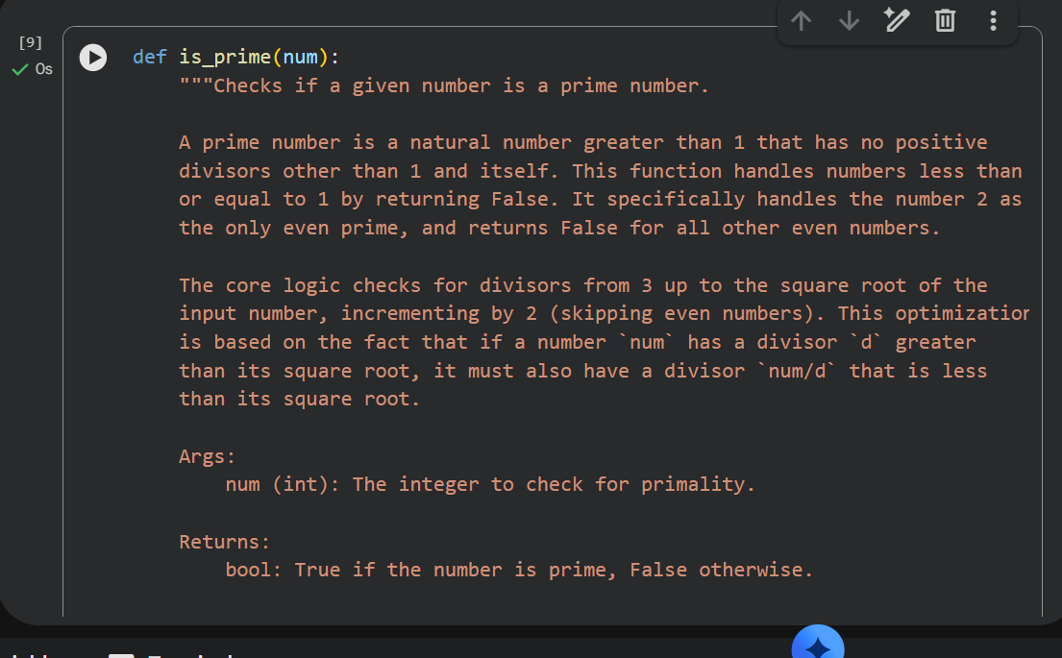
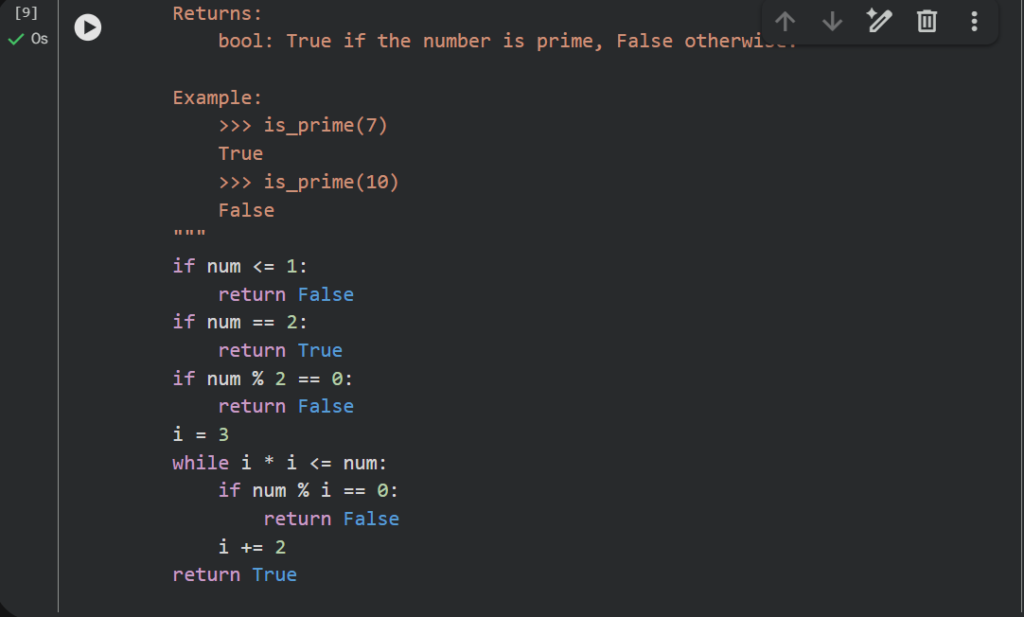
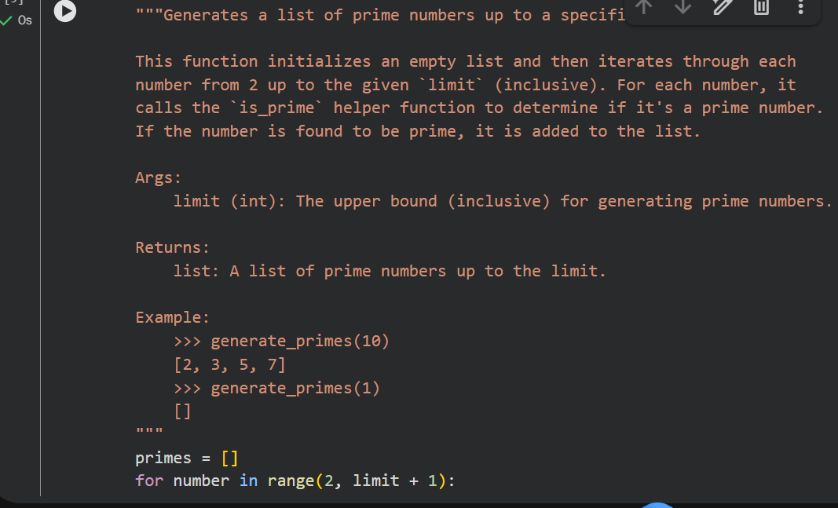
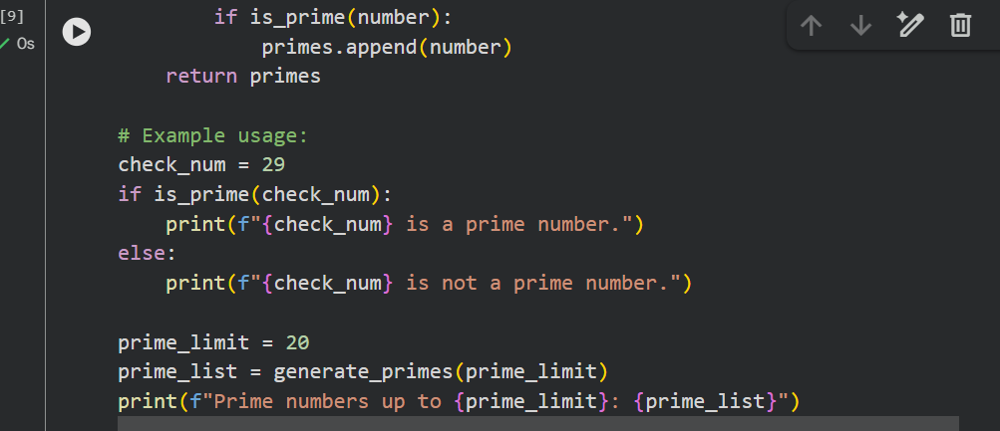

Output

Justification
The function now follows standardized documentation practices, improving consistency across the codebase.

Task 5: Building a Mini Automatic Documentation Generator

Scenario
Your team wants a simple internal tool that helps developers start documenting new Python files quickly, without writing documentation from scratch.

Prompt
Write a Python script that reads a .py file, detects functions and classes, and inserts placeholder Google-style docstrings.

Python utility
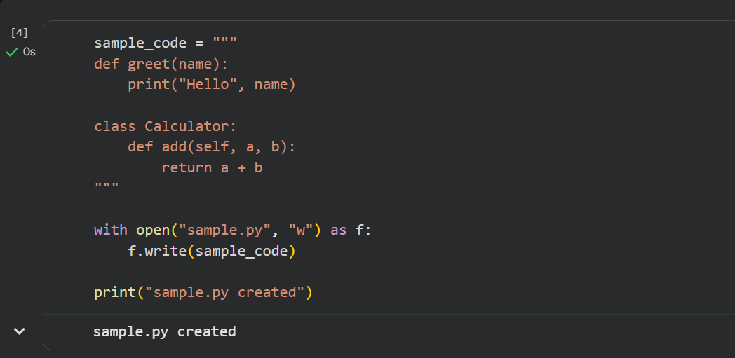
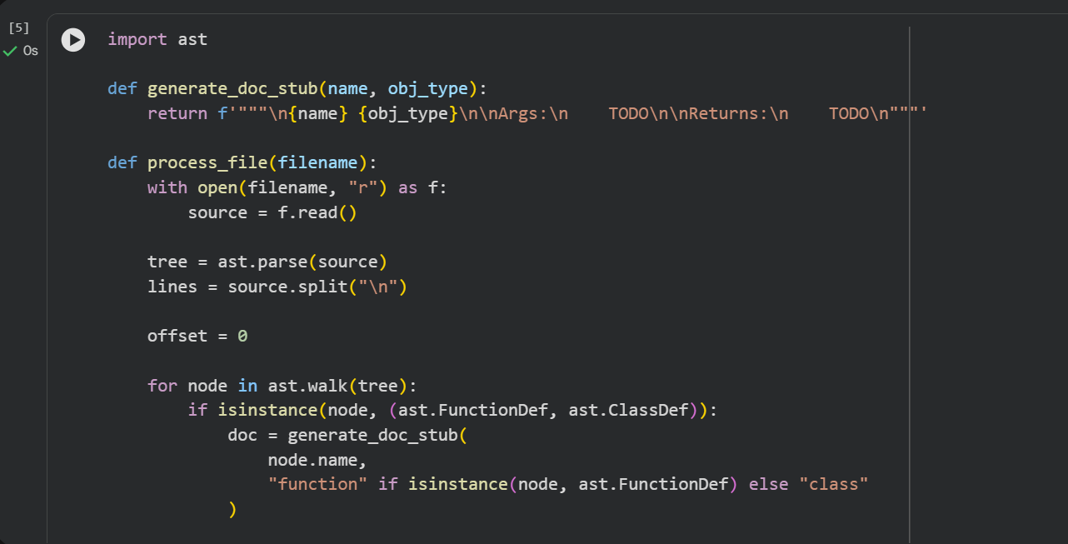
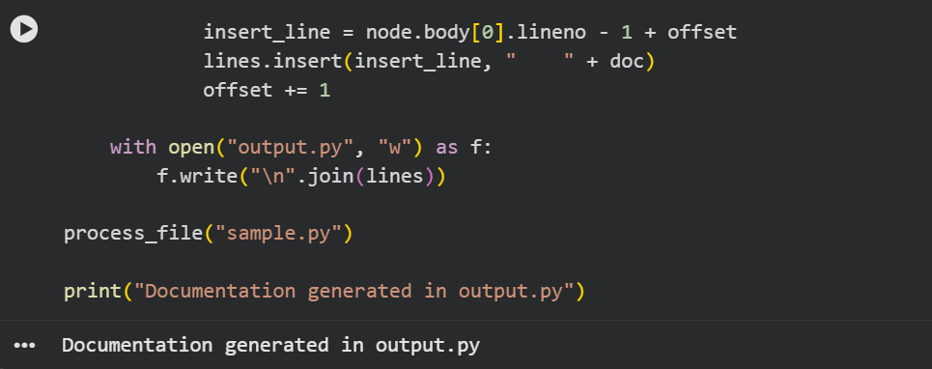
AI used to assist in generating or refining this utility.
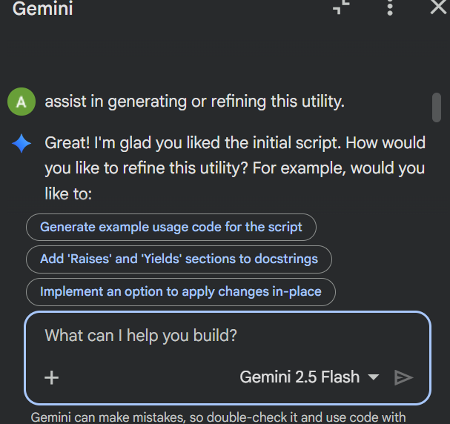

Output
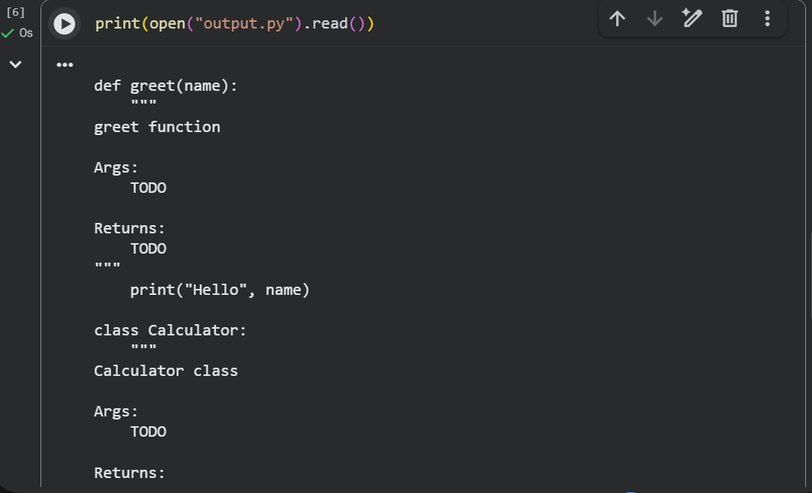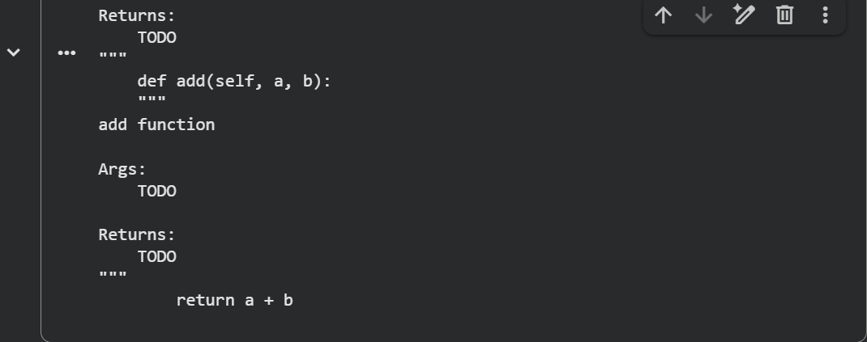

Justification
This task demonstrates how AI-assisted tools can automate documentation generation. The script reads a Python file, detects functions and classes using the ast module, and inserts placeholder docstrings. This reduces manual documentation effort and ensures consistent documentation structure.

